ER DIAGRAM FOR TWITTER CLONE

Entities:

1. User:

- Attributes: UserID (Primary Key), Username, Email, Password, Bio, JoinDate, ProfilePicture, etc.

2. Tweet:

- Attributes: TweetID (Primary Key), UserID (Foreign Key), TweetText, Timestamp, Location, LikeCount, RetweetCount, etc.

3. Follow:

- Attributes: FollowID (Primary Key), FollowerUserID (Foreign Key), FollowingUserID (Foreign Key), FollowDate

4. Hashtag:

- Attributes: HashtagID (Primary Key), HashtagText

5. Like:

- Attributes: LikeID (Primary Key), UserID (Foreign Key), TweetID (Foreign Key), LikeDate

6. Retweet:

- Attributes: RetweetID (Primary Key), UserID (Foreign Key), TweetID (Foreign Key), RetweetDate

Relationships:

- A User can create many Tweets (One-to-Many relationship).

- A Tweet belongs to one User who created it (Many-to-One relationship).

- A User can follow zero or more other Users, and a User can be followed by zero or more other Users (Many-to-Many relationship through the Follow entity).

- A Tweet can have zero or more Likes (Many-to-Many relationship through the Like entity).

- A Tweet can be retweeted by zero or more Users (Many-to-Many relationship through the Retweet entity).

- A Tweet can contain zero or more Hashtags, and a Hashtag can be associated with zero or more Tweets (Many-to-Many relationship through an associative table).

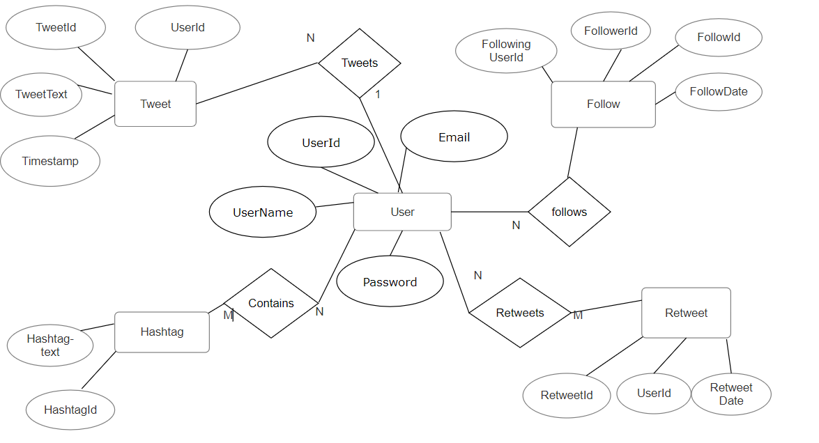

Database Diagram 1

**4.1 Database Table**

**4.1.1 Login Table**